

**PROJECT REPORT**

**1** **INTRODUCTION**

1.1 Overview

Creating a resume or CV using Canva

1.2 Purpose

The main purpose of this project is to make the students to create a proper and professional resume.

**2 PROBLEM DEFINITION &DESIGN THINKING**

2.1 Empathy Map

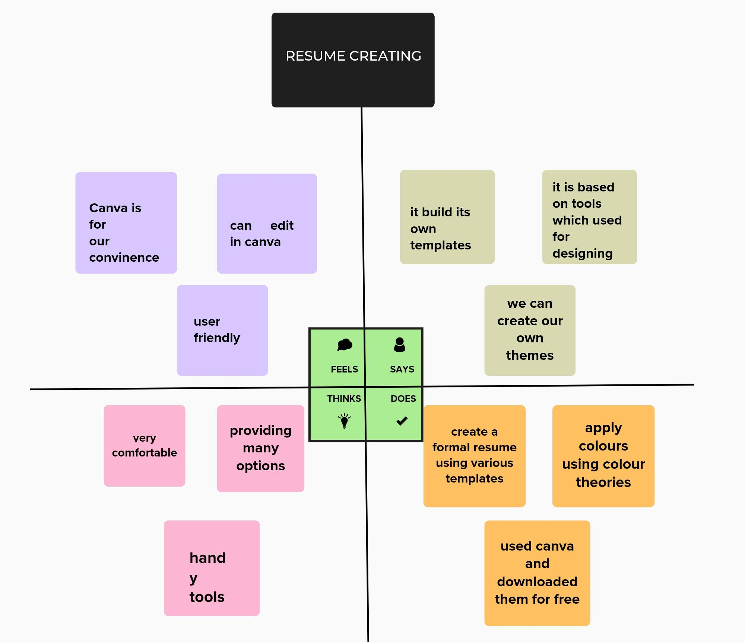

2.2 Ideation & Brainstorming Map

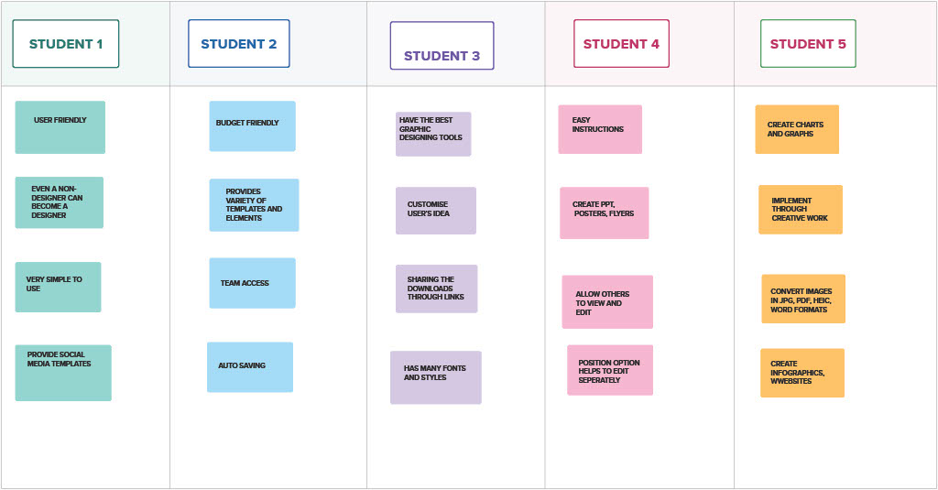



**PROJECT REPORT**



# 3 RESULT

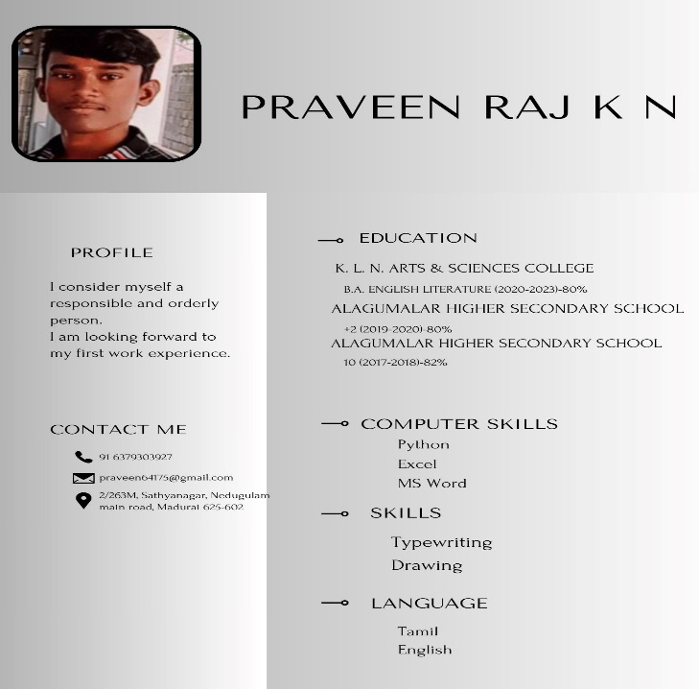

# 4 ADVANTAGES & DISADVANTAGES

Building an own resume is difficult for many students. But Canva provides templates of the correct sizing for other online platforms. It has so many options to create our designs, and provide an user friendly platform.

The disadvantage in canva can be seen in the people who were using the app in their mobile. The detailing effects cannot be properly aligned in the mobile.

# 5 APPLICATIONS

Beginners can easily edit like professionals. And also, it has many of templates such as creative, simple, professional, etc. suitable for everyone.

# 6 CONCLUSION

It is a user-friendly platform for beginners to learn.